Important thing :

t,F ,short answers ,long short answers ,MCQ, Fill the void (فراغات).

Week2:

what is data base management system(DBMS)?

* **DBMS** contains information about a particular enterprise
  + Collection of interrelated data.
  + Set of programs to access the data.

The difference between data base system and file system?**by Nisreen AlGhadban**

|  |  |  |  |  |  |  |
| --- | --- | --- | --- | --- | --- | --- |
|  | **DBMS** |  |  | **File system** |  |  |
|  |  |  |  |  |
|  |  |  |  |  |  |  |
|  | **Used collection of database to store** |  |  | **Used files to store data** |  |  |
|  | **data** |  |  |  |  |  |
|  |  |  |  |  |  |  |
|  | **Redundancy is controlled** | |  | **Data redundancy & inconsistency** | |  |
|  |  | |  |  | |  |
|  | **Providing multiple user interfaces** |  |  | **Data isolation** |  |  |
|  |  |  |  |  |  |  |
|  | **Providing backup and recovery** | |  | **Concurrent access is not possible** | |  |
|  |  | |  |  | |  |
|  | **Most tasks are done automatically** |  |  | **Most tasks are done manually** |  |  |
|  |  |  |  |  |  |  |
|  | **Avoided problems like data integrity,** | |  | **Leads to problems like data integrity,** | |  |
|  | **data inconsistency and data security** | |  | **data inconsistency and data security** | |  |
|  |  | |  |  | |  |
|  | **Unauthorized access is restricted** |  |  | **Difficult in access data** |  |  |
|  |  |  |  |  |  |  |
|  | **Complicated** | |  | **Easy to use** | |  |
|  |  | |  |  | |  |
|  | **Expensive system** |  |  | **Cheap system** |  |  |
|  |  |  |  |  |  |  |
|  | **Supports multi access for users** | |  | **Multi user is not supported** | |  |
|  |  | |  |  | |  |
|  | **Suitable for large database** |  |  | **Only suitable for small database** |  |  |
|  |  |  |  |  |  |  |
|  | **Adjustable** | |  | **Non-adjustable** | |  |

Ex for **file system** = MS-Dos , Is organization **hierarchically**.

And now the **disadvantage for file system** ?

is **Drawbacks of using file systems to store data**

* + Data redundancy and inconsistency
  + Difficulty in accessing data
  + Data isolation — multiple files and formats
  + Integrity problems
  + Atomicity of updates
  + Concurrent access by multiple users

Level of abstraction?

* **Physical level:** describes how a record (e.g., customer) is stored.
* **Logical level:** describes data stored in database, and the relationships among the data.
* **View level:** application programs hide details of data types. Views can also hide information (such as an employee’s salary) for security purposes.

Now the meaning of

* **Schema** – the logical structure of the database
  + **Instance** – the actual content of the database at a particular point in time.( Analogous to **the value of a variable**)

Understanding DML,DDL,SQL:

**Data Manipulation Language (DML)**:

* Language for accessing and manipulating the data organized by the appropriate data model
  + DML also known as query language

**Data Definition Language (DDL)**:

* Specification notation for defining the database schema
* DDL compiler generates a set of table templates stored in a ***data dictionary***
* Data dictionary contains metadata (i.e., data about data)

**SQL**(structured Query language):

widely used non-procedural language.

* Application programs generally access databases through one of
  + Language extensions to allow embedded SQL
  + Application program interface (e.g., ODBC/JDBC) which allow SQL queries to be sent to a database

**Storage Management** is responsible

* The storage manager is responsible to the following tasks:
  + Interaction with the file manager
  + Efficient storing, retrieving and updating of data

May short Q List the issues :

* Issues:
  + Storage access
  + File organization
  + Indexing and hashing

**Understanding :**

**Transaction Management slid 23:**

* **A transaction is a collection of operations that performs a single logical function in a database application.**

**Database Architecture** slid 26

The architecture of a database systems is greatly influenced by the underlying computer system on which the database is running:

* Centralized
* Client-server
* Parallel (multi-processor)
* Distributed

He told us about slid 24,27 but I think he mean slid 23,26.

Week 3 & 4: relational model

**Important Terminology:**

Relations

**Attribute= columns(there are value in a columns)**

**Tuples= rows()**

**Important : Domain= The set of allowed values for each attribute**

**Important : Atomic= values that are indivisible.**

**مثال ع الاوتيمك دا المثال أي تي ارقام يمكن تجزئته لقسمين أحروف و أرقام – و لانو الأوتوميك غير قابل للتجزئه فإن المثال المعطى ليس اتوميك**

**Ex: IT244 (no Atomic)**

**Keys:**

**primary key: unique key. Ex : like student ID (can't student share the number for ID )**

**super key : a key that is sufficient to identify a unique tuple . like in the student table have attribute as ID, name : the name can be enough to identify a unique tuple.**

**candidate (المرشح)key : subset of super key** **is minimal.**

**Ex: like we have a student table we have : Student_ID , F_name,L_name,session . the Q what are the candidate key in this table? Can be a candidate key Student_ID , F_name,L_name.**

**Foreign key: is a Value in one relation that appear in another relation.**

**Ex: we have two table the first one name student table include Student_ID , F_name,L_name,session.**

**The second table name session include session_no,Room. The primary key in this table is session number couse it is unique so when we used the session in the first table that session become foreign key.**

**Very very very : important : Slid 8 : Relational Query Languages.**

**Selection of tuples= σ A=B and D > 5 (r)**

1. **we have name relation as r.**

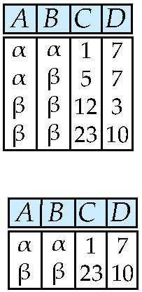 **Select tuples with A=B and D > 5**

**هنا لمن نختار سيلكشن للصفوف بيكون رمزها σ و فوق أعطانا شروط للصف وهي with A=B and D > 5 طبعا هنا شرطين الاول انو أي بيساوي بي و الثاني لمن قيم دي بتكون أكبر من 5 إذا تحقق الشرطين فإننا نصيغ العلاقه دي بالصيغه رمز السيلكشن و بعدو الشروط و بين قوسين اسم العلاقه :**

**σ A=B and D > 5 (r)**

**Selection of Columns (Attributes)** = Π A, C (r)

* the Q Select A and C

Projection r

Π A, C (r)

هنا لمن بالاخير نجمع العامودين نلاقي تكرار و اذا وجد ناخود قيمة وحده بس

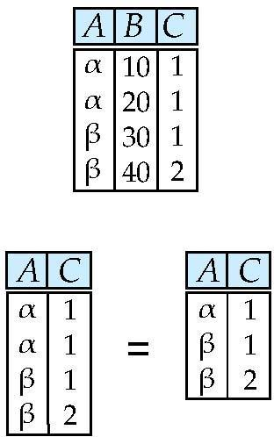

**Joining two relations – Cartesian Product**= ***r* x *s***

Relations *r, s*:

*r* x *s*

مايحضرني الصورة للجدول حاولوو تشوفوها هنا في دي العلاقه حا نمسك اول صف في العلاقه ار و نضربو بجميع الصفوف في العلاقه اس و بعدين نرجع للعلاقه ار و ناخود ثاني صف و نرجع نضربو في كل الصفوف للعلاقه اس :

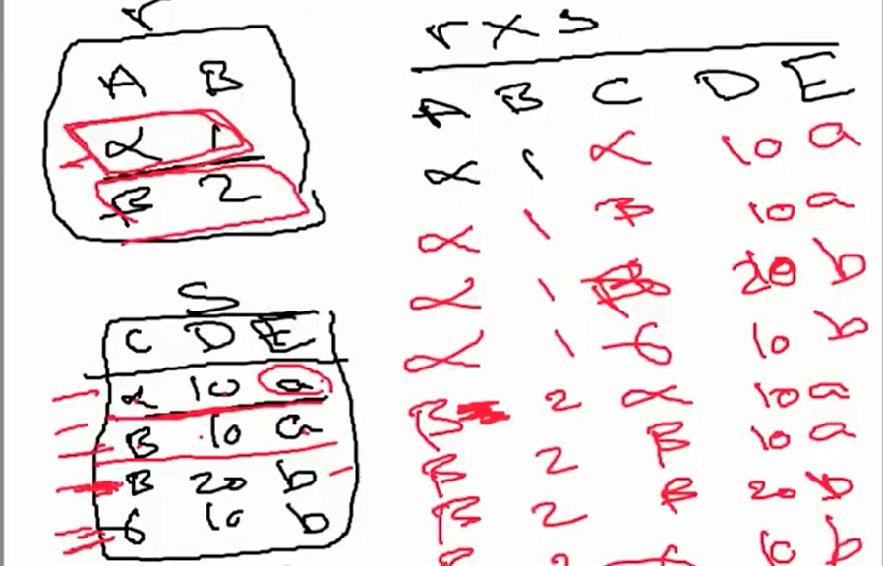

**Union of two relations**= r ∪ s

Relations *r, s:*

r ∪ s:

كمانا هنا لو فيه تكرار ما ناخدو ناخد منو قيمة واحدة بس

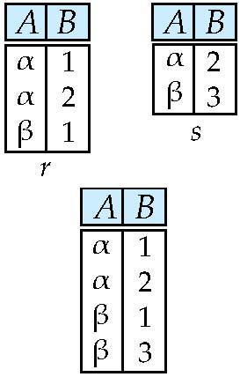

**difference of two relations** = *r – s*

* Relations *r*, *s*:
* *r – s:*

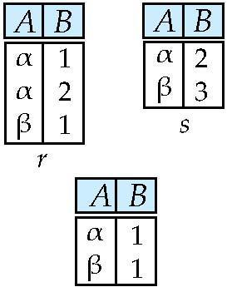

**Set Intersection of two relations**= *r* ∩ *s*

Relation *r, s*

*r* ∩ *s*

*هنا العلاقتين تتقاطعان بقيمة مشتركة و نكتوبها*

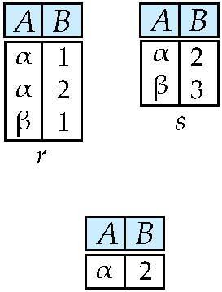  
**Natural Join** :

r علامة العلاقه ناتشورل s

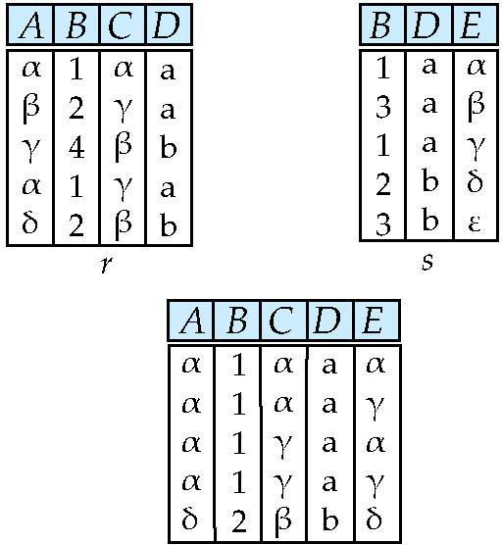

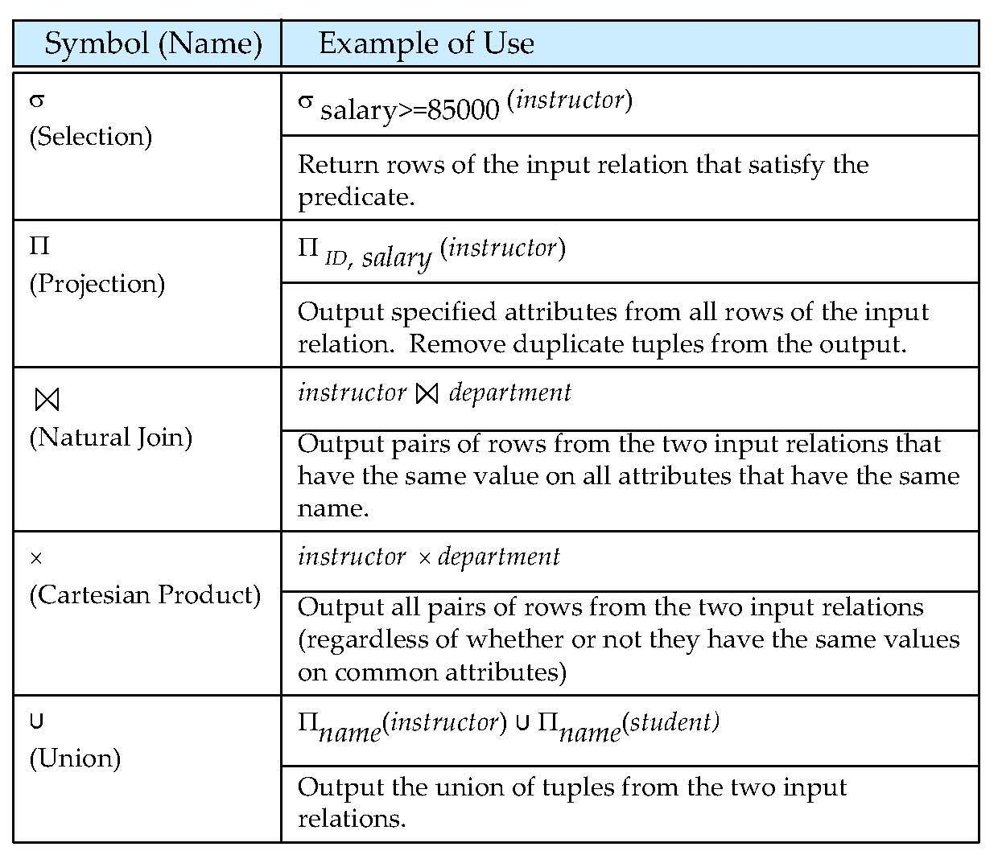

The different between Procedural vs. non-procedural?

* + **Procedural** –DR ali Define as : **specifies the operations to be performed on the data and the sequence of operations**. And on slide in week 2 define like this: user specifies what data is required and how to get those data
  + **Declarative (nonprocedural)** – DR Ali define as : specify the resulte only without to need now how to begging this result. The another define in week 2 is : user specifies what data is required without specifying how to get those data

Weeks 5&6: **Entity-Relationship Model** and data base design:

**Entity** : is an object that exists and is distinguishable from other objects.

Ex : specific persone.

An **entity set** is a set of entities of the same type that share the same properties.

Ex: set of all persons

**I feel this coming : binary relationship** : Relationships between more than two entity sets.

**Type attributes**: are two type dr ali say : are **simple(single value ) and composite (multivalue)**.

I put the slid talk about it .

* Attribute types:
  + **Simple** and **composite** attributes.
  + **Single-valued** and **multivalued** attributes
    - Example: multivalued attribute: *phone_numbers*
  + **Derived** attributes
    - Can be computed from other attributes
    - Example: age, given date_of_birth

Relationship types:

* + One to one

Ex:

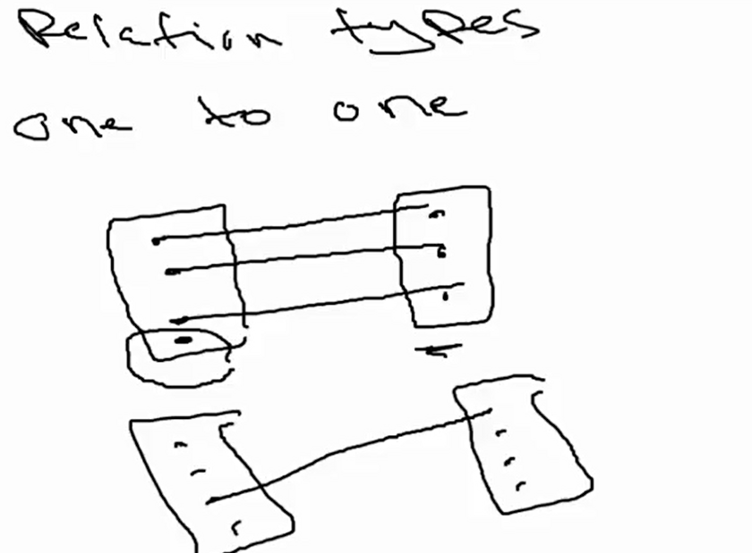

* + One to many

Ex:

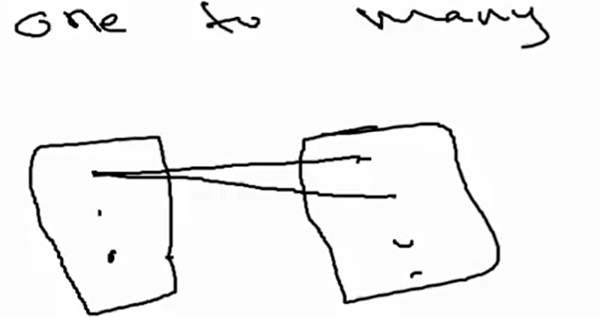

* + Many to one

Ex:

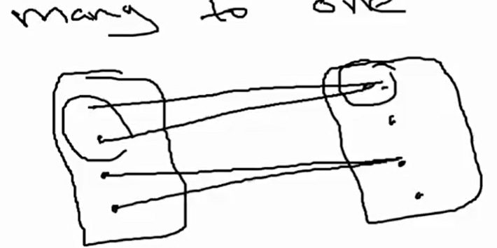

* + Many to many

Ex:

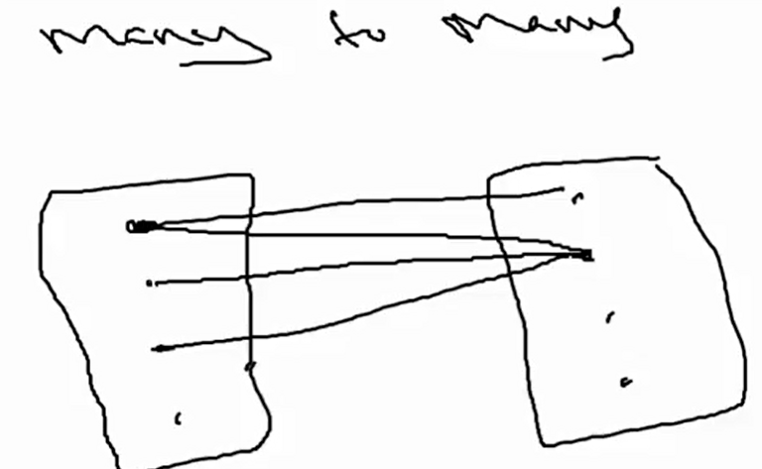

**Difine**

**Redundant = Redundant Attributes** (زيادة أو مكررة):

**Important sample :**

**احتمال يجبلنا رسمه و احنا نجاوب ع الاسئلة او اسئلة و إحنا نرسم فا لازم نعرف الرموز لها**

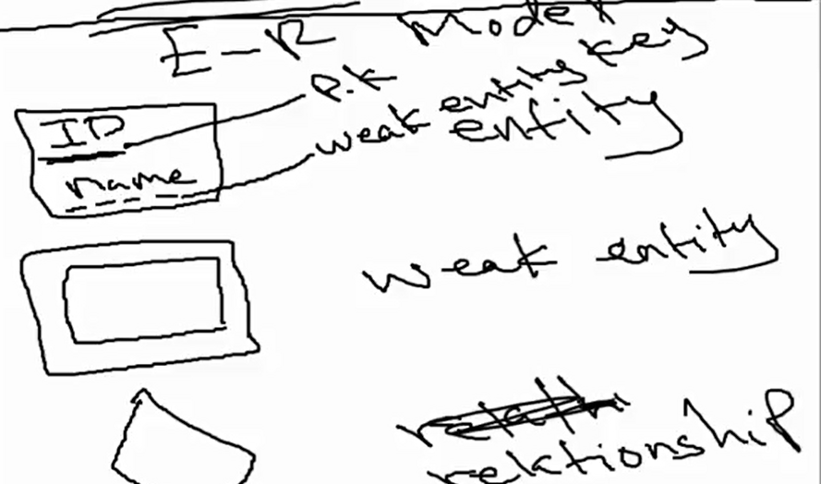

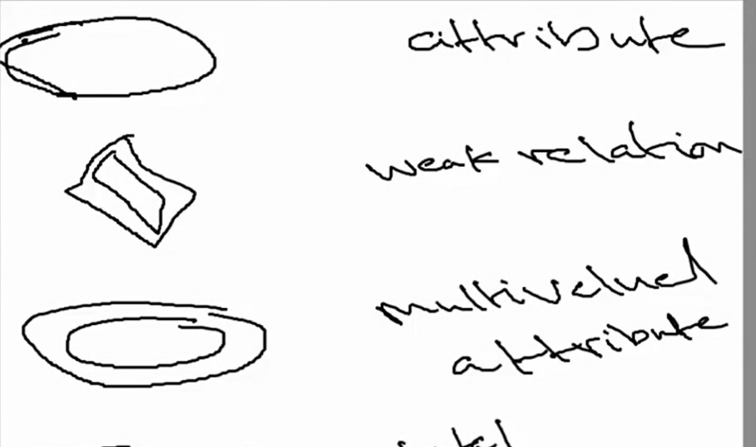

(ERM)

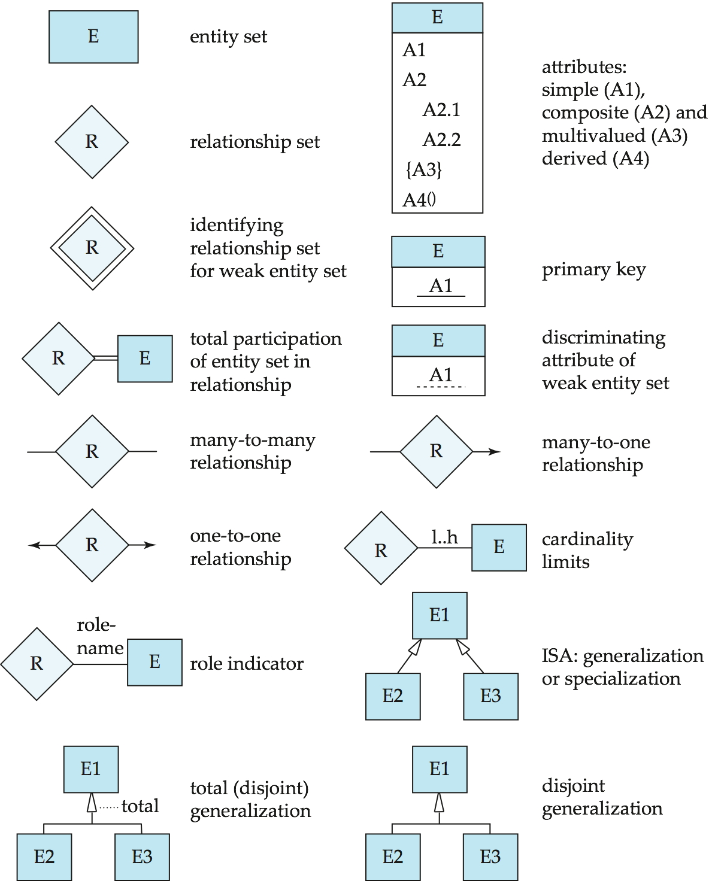



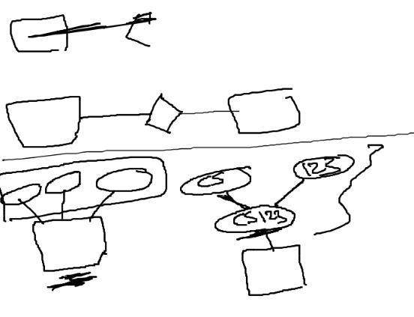

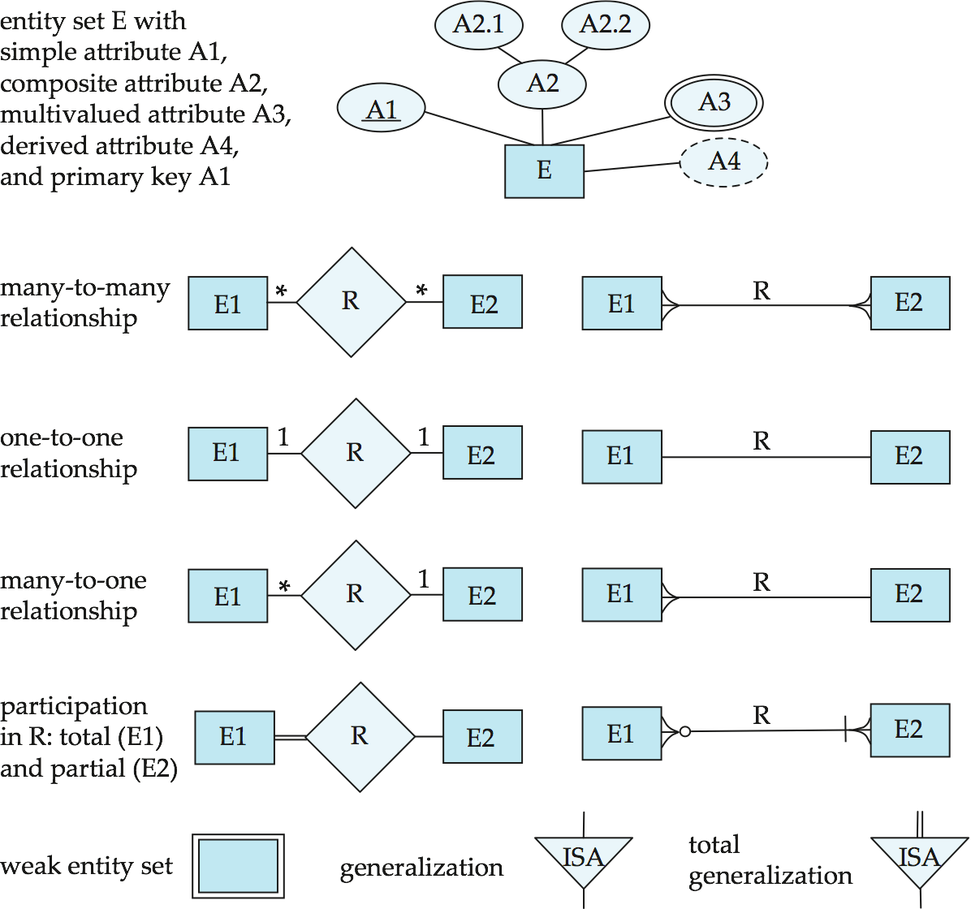

**Redundancy of Schemas**(no in exam)

**Design Issues**(مو داخل معانا)

**Converting Non-Binary Relationships**(no in exam)

**Extended ER Features**: now about it.

* **Specialization**.
* Top-down design process; we designate subgroupings within an entity set that are distinctive from other entities in the set.
* **Attribute inheritance** – a lower-level entity set inherits all the attributes and relationship participation of the higher-level entity set to which it is linked.

**Ex**:

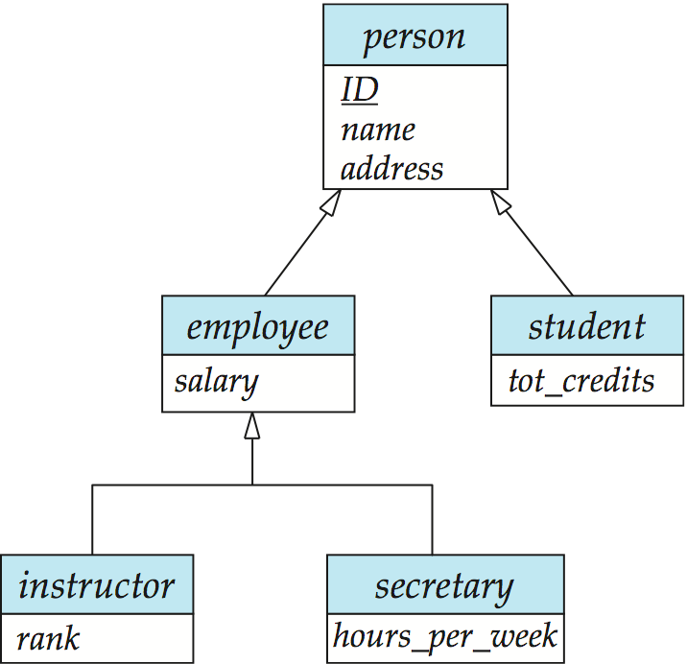

* **Generalization:**
* **A bottom-up design process** – combine a number of entity sets that share the same features into a higher-level entity set.
* The terms specialization and generalization are used interchangeably.
* The ISA relationship also referred to as **superclass - subclass** relationship

Important **Terminology**:MCQ or full the void ☺ this is coming I feel that:

**Disjoint**: an entity can belong to only one lower-level entity set

**Overlapping**: an entity can belong to more than one lower-level entity set

**Completeness constraint**: specifies whether or not an entity in the higher-level entity set must belong to at least one of the lower-level entity sets within a generalization.

**Aggregation**(مو داخل لاختبار )

**UML**: لازم تعرفو عنوعن نفسي اخترت دي النقاط افهمها و تكفي لانو ما أعتقد حا يتعمق بيها

* **UML**: Unified Modeling Language
* UML has many components to graphically model different aspects of an entire software system
* UML Class Diagrams correspond to E-R Diagram, but several differences.

Week 7: **Relational Database Design**(DB normalization)

You should to now : **: this is more important**

**Functional Dependencies ☺ (is attribute define the other attribute or attribute depend to the other attribute as α → *β*holds on *R* ).**

**I choose from the slid this about Functional Dependencies :**

* **Constraints on the set of legal relations.**
* **Require that the value for a certain set of attributes determines uniquely the value for another set of attributes.**
* **A functional dependency is a generalization of the notion of a *key.***

**First Normal Form**(1 NF)

* The domains of all attributes are atomice
* No repetition.

Ex: car

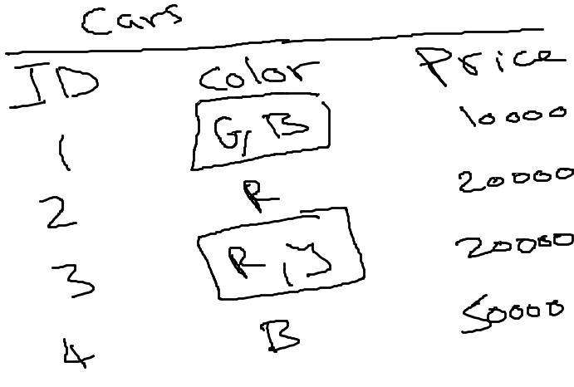

This is no 1 FN look at the table there are to color (G,B ) so the attribute can seprate so this is not atomic . to make the table look like 1 NF by create two table :

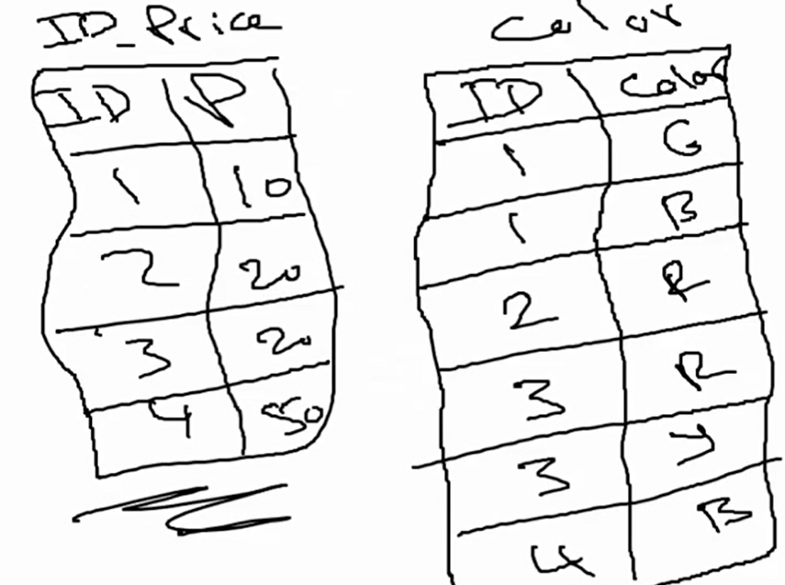

**2NF:**

It has to **be in 1NF**.

All non-key attributes must **depend on the primary key**.

Ex:

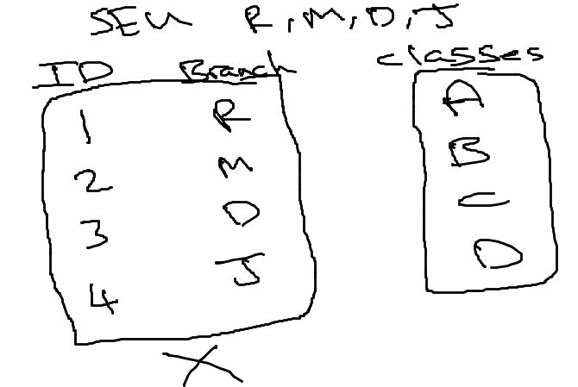

To be in 2NF:

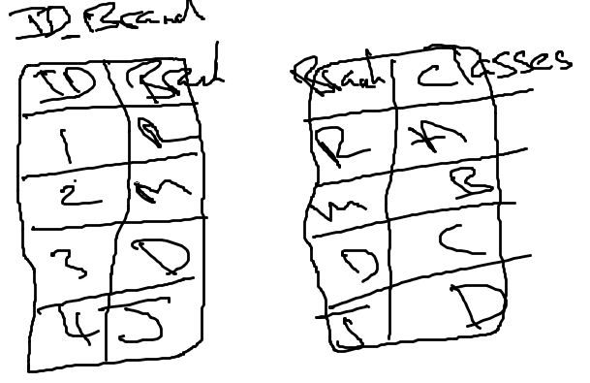

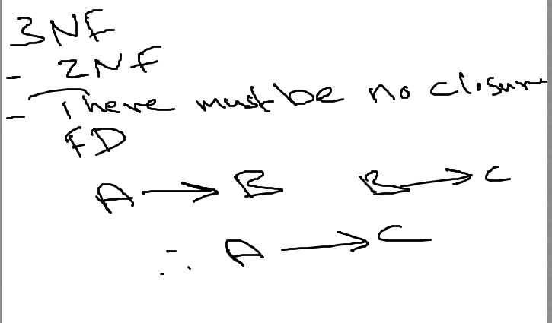

Ex:

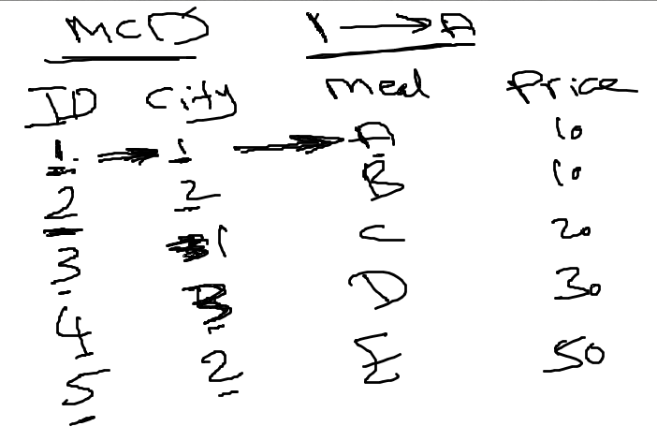

ID --> cirty . cirty --> meal . ID --> meal

So 1- A = this is no 3NF can Happened.

So we make two table for to be 3NF:

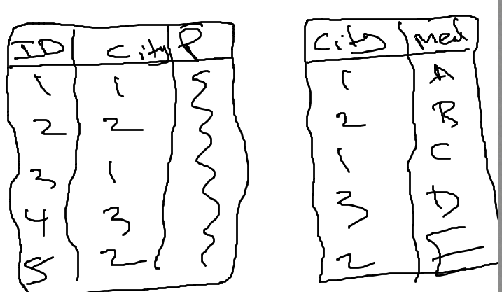

**Boyce-Codd Normal Form**(no in exam )

Very ,very ,very important I feel is coming : **Closure of a Set of Functional Dependencies** We can find F*+,*  **the closure of F**, by repeatedly applying **Armstrong’s Axioms:**very important

* + if *β* ⊆ α, then α → *β* **(reflexivity)**
  + if α → *β,* then γ α → γ *β* **(augmentation)**
  + if α → *β,* and *β* → γ, then α → γ **(transitivity)**

ex in slide (27) to understand :

* *R = (A, B, C, G, H, I)  
  F =* { *A* → *B  
   A* → *C  
   CG* → *H  
   CG* → *I  
   B* → *H*}

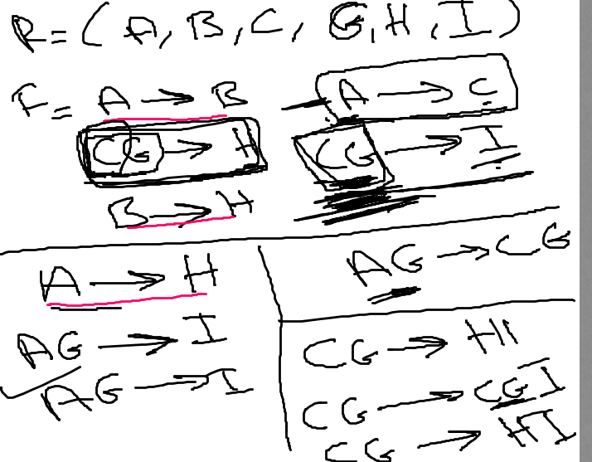

I feel this Q from our HM may coming this is just my feeling:

1**. Use Armstrong’s axioms to prove the soundness of the pseudotransitivity rule.**

**If α → β and γ β → δ, then α γ → δ.**

**Canonical Cover**(no in our exam )

**Computing a Canonical Cover** (no in exam)

**Lossless-join Decomposition**(no in exam)

No in our exam = منو داخل معانا

Good Luck ☺